**Assignment 5.3**

**Ques 1:**

**load_data = LOAD '/home/acadgild/hadoop/Pokemon.csv' USING PigStorage(',') AS (Sno:int, name:chararray, type1:chararray,**

**type2:chararray, total:chararray, hp:int, attack:int,defence:int,spattk:int,spdef:int,speed:int);**

**selRel = FILTER load_data BY defence>55;**

**DUMP selRel;**

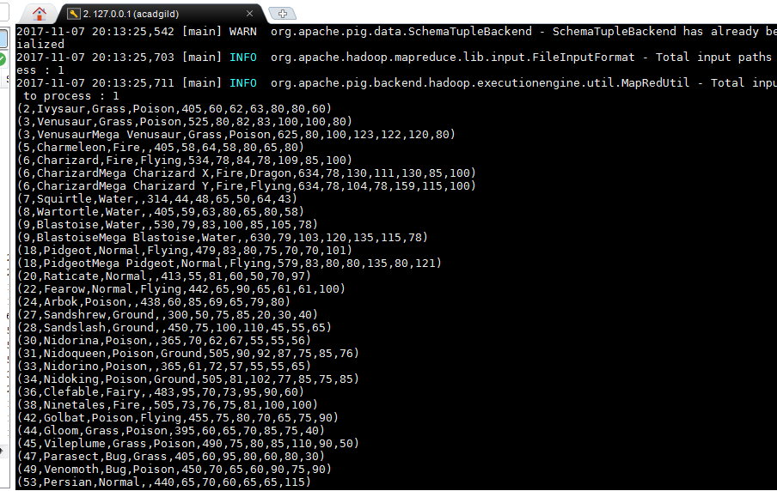

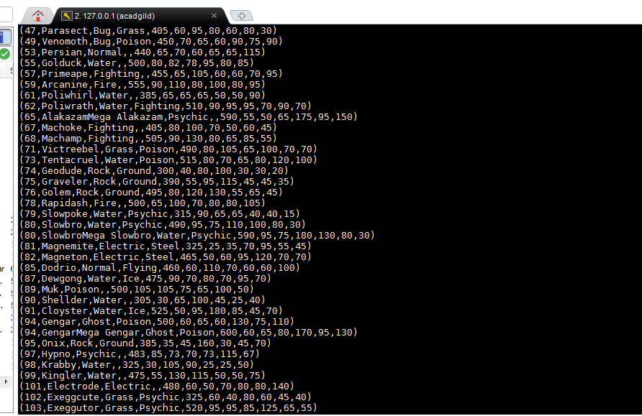

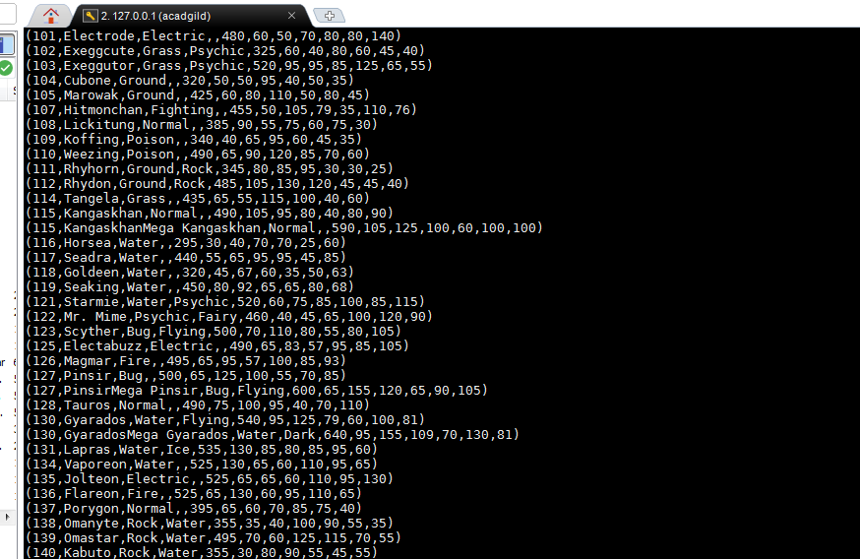

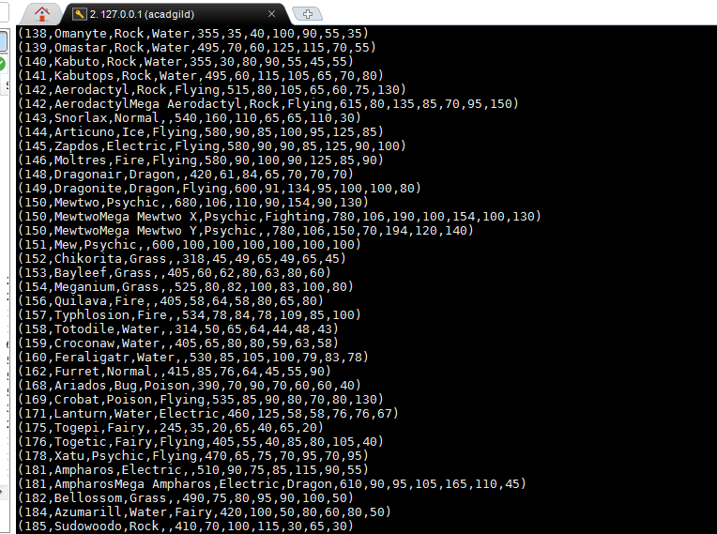

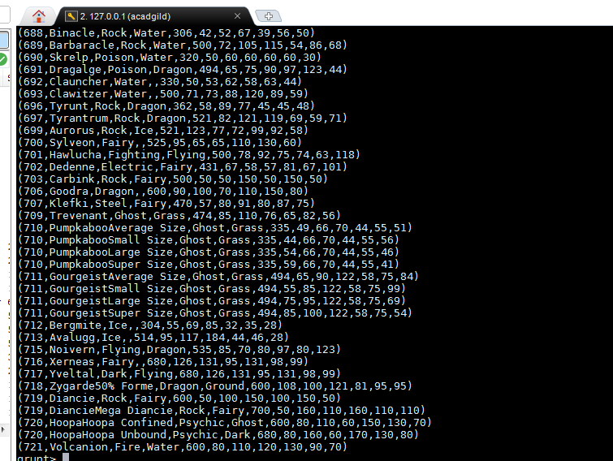

**Ques 2:**

**group_selRel = group selRel All;**

**count_selRel = FOREACH group_selRel GENERATE COUNT(selRel);**

**DUMP count_selRel;**

**Ques 3:**

**random_include1 = FOREACH selRel GENERATE RANDOM(),name,type1,type2,total,hp,attack,**

**defence,spattk,spdef,speed;**

**DUMP random_include1;**

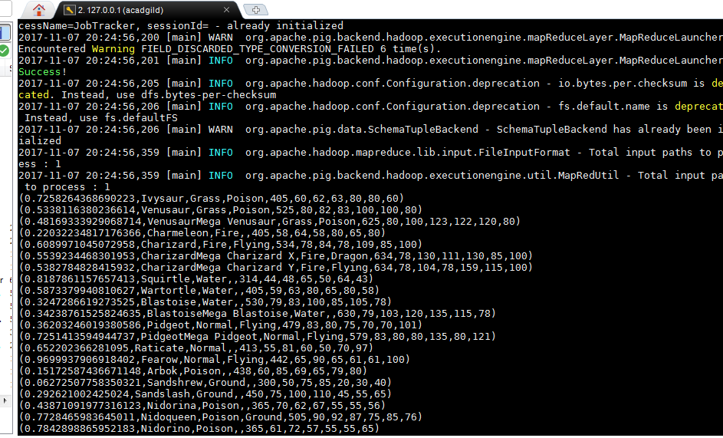

**Ques 4:**

**random_desc = ORDER random_include1 by $0 DESC;**

**DUMP random_desc;**

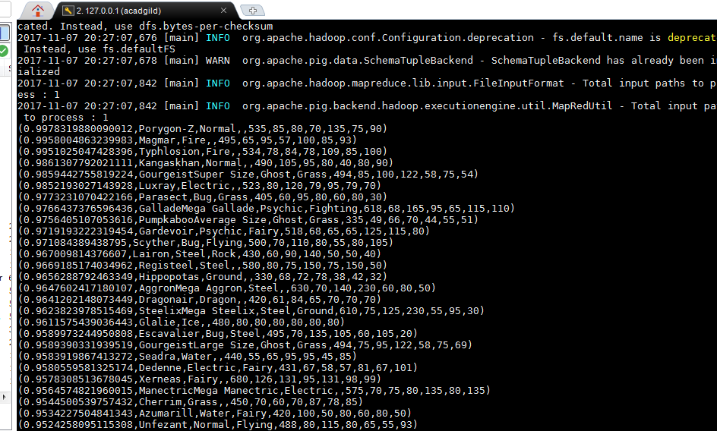

**Ques 5:**

**random_include2 = FOREACH selRel GENERATE RANDOM(),name,type1,type2,total,hp,attack,**

**defence,spattk,spdef,speed;**

**random2_desending = ORDER random_include2 BY $0 DESC;**

**DUMP random2_desending;**

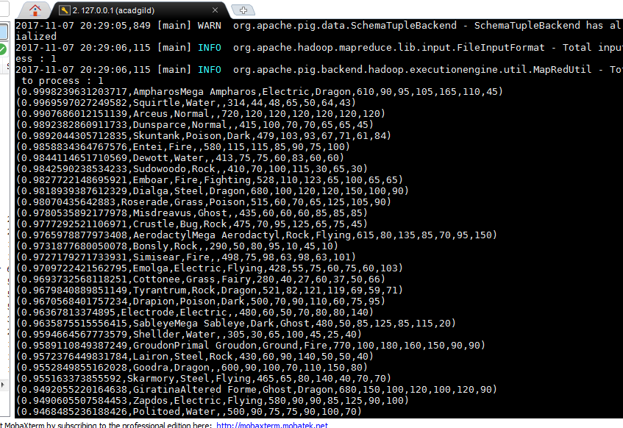

**Ques 6:**

**limit_data_random1_desending = LIMIT random_desc 5 ;**

**DUMP limit_data_random1_desending;**

**limit_data_random2_desending = LIMIT random2_desending 5 ;**

**DUMP limit_data_random2_desending;**

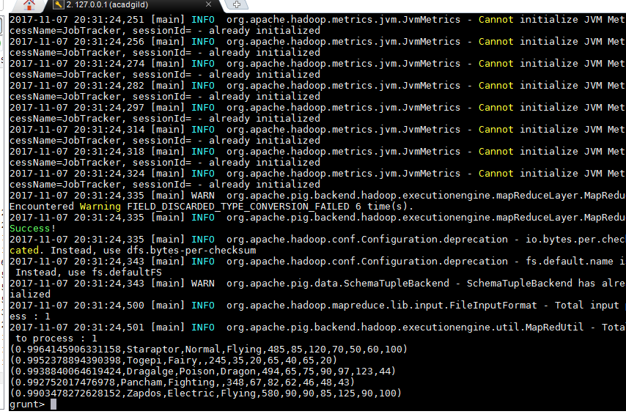

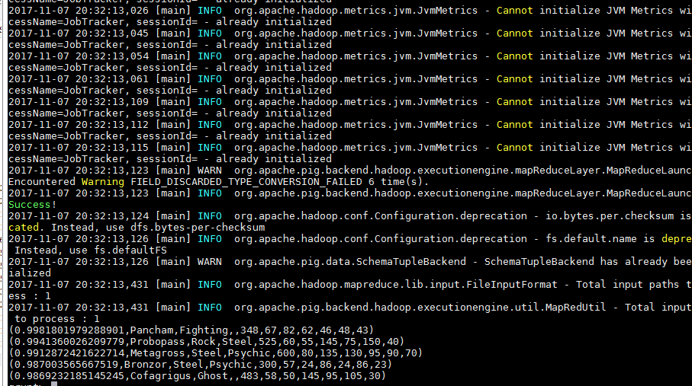

**Ques 7:**

**filter_only_name1 = foreach limit_data_random1_desending Generate ($1,hp);**

**DUMP filter_only_name1;**

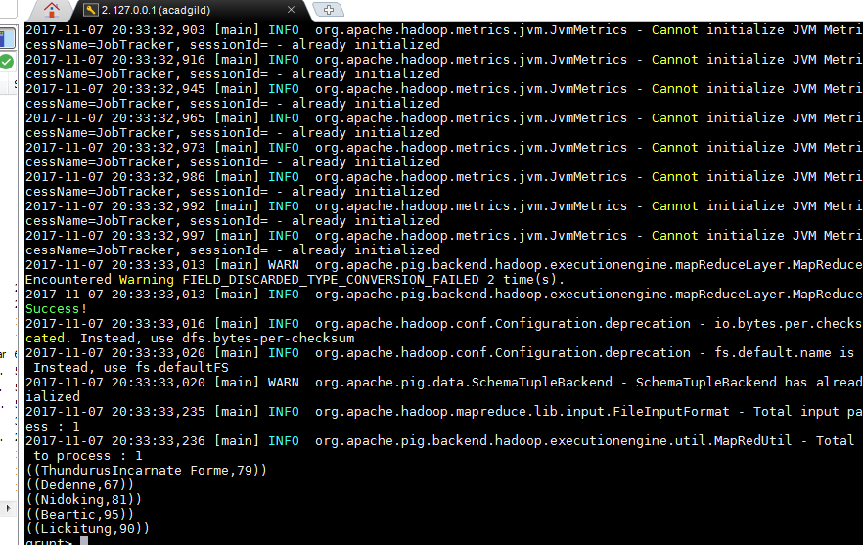

**STORE limit_data_random1_desending INTO '/home/acadgild/hadoop/player1.txt';**

